

HAWASSA UNIVERSITY

INSTITUTE OF TECHNOLOGY

FACULTY OF INFORMATICS

DEPARTMENT OF INFORMATION sysTEM

Project Title: ANDROID AND WEB BASED CINEMA SEAT RESERVATION AND PAYMENT SYSTEM

A PROJECT SUBMITTED IN PARTIAL FULFILLMENT OF THE REQUIREMENT FOR THE AWARD OF BACHELORS OF SCIENCE (B.Sc.) IN INFORMATION SYSTEM

**Group Members**

**No Name ID No Signature**

1. **Abdella *Munir InSyR/0001/11***
2. ***Dagnachew Kebede InSyR/0021/11***
3. ***Nebiyou Solomon InSyR/0043/11***
4. ***Yordanos Asmamaw InSyR/0062/11***

**Advisor Mr. Demewoz Beldados (MSc/PhD)**

**Submitted to: Information System Department**

**Submission date: February 7, 2022**

**Hawassa, Ethiopia**

Approval letter

This is to certify that the project is original and has not submitted for partial fulfillment of Bachelor of Science in computer science. Our project members name and Signature.

Name Signature

1. **Abdella Munir**
2. **Dagnachew Kebede**
3. **Nebiyou Solomon**
4. **Yordanos Asmamaw**

Faculty: Faculty of Informatics

Department: Information System

Project web and android based cinema reservation and payment system

I certify that this project satisfies all the requirements as a project for the degree of Bachelor of Science in Information System.

Name of program coordinator Signature

------------------------------------- ----------------------

This is to certify that I have read this project and that in my opinion; it is fully adequate, in scope and quality, as a thesis for the degree of Bachelor of Science (B.Sc.) in Information system.

------------------------------------- -----------------------

Name of Advisor Signature

Examining committee members Signature Date

1. Chairman ____________ ____________ __________

2. Examiner 1 ____________ ____________ __________

3. Examiner 2 ____________ ____________ ___________

4. Examiner 3 ____________ ____________ ___________

It is approved that this project has been written in compliance with the formatting rules laid down by the Faculty of Informatics.

**Acknowledgement**

First and foremost, we would like to thanks our Almighty GOD for giving all the capabilities to do things and helped us from the start to the end. Next to GOD We wish to express our sincere gratitude to the Faculty of information systems, for providing as an opportunity to perform our project work on “Web and android based cinema reservation and payment system” .We sincerely thank our project Advisor, Mr. Demewoz Beldados for his diligence in advising and guiding us through the right path, from the inception until the completion of this document.

We would also like to express gratitude and appreciation to our department members and class mates for their valuable advice and guidance. Additionally we would like to thank our parents, Friends and those who helped us directly and indirectly for the successful completion of this project work. The completion of this project would not have been possible without the Kind support and help of many individuals and organizations. We would like to extend our honest thanks to all of them.

Table of Contents

CHAPTER ONE 1

1. INTRODUCTION 1

1.1. BACKGROUND OF THE PROJECT 2

1.2. STATEMENT OF THE PROBLEM 3

1.3. OBJECTIVE OF THE PROJECT 4

1.3.1 GENERAL OBJECTIVE 4

1.3.2 SPECIFIC OBJECTIVE 5

1.4. SCOPE OF THE STUDY 5

1.5. LIMITATION OF THE STUDY 6

1.6 SIGNIFICANCE OF THE PROJECT 7

1.7. METHEDOLOGY 8

1.7.1. DATA COLLECTION METHEDOLOGY 8

1.7.2. SYSTEM ANALYSIS AND DESIGN METHEDOLOGY 9

1.7.3. DEVELOPMENT TOOL AND TECHNOLOGIES (WORKING ENVIROMENT) 10

1.7.4. SYSTEM IMPLEMENTATION 11

1.7.5. TESTING AND DEPLOYMENT METHEDOLOGY 12

1.7.6 SECURITY METHEDOLOGY 15

1.7.7 BACKUP AND RECOVORY METHEDOLOGY 15

1.8 SYSTEM REQUIRMENT 16

1.8.1. SOFTWARE REQUIRMENT 16

1.8.2. HARDWARE REQUIRMENT 17

1.9. FEASIBILITY STUDY 17

1.9.1 TECHNICAL FEASIBILITY 18

1.9.2. OPERATIONAL FEASABILITY 18

9.3. ECONOMIC FEASABILITY 19

1.10. COST ESTIMATION AND SCHEDULE BREAKDOWN 20

1.10.1 COST ESTIMATION 20

1.10.2. SCHEDULE BREAKDOWN 22

CHAPTER TWO 23

2. DESCRIPTIONS OF EXSTING SYSTEM 23

2.1. Introduction of the Existing System 23

2.2. Proposed System Description 24

2.3. Strength of Existing System 25

2.4. Weakness of Existing System 25

CHAPTER THREE 27

3. SYSTEM FEATURES 27

3.1 INTRODUCTION 27

3.2 FUNCTIONAL REQUIRMENTS 28

3.3 NON-FUNCTIONAL REQUIRMENTS 29

3.4. SYSTEM ANALYIS MODEL 31

3.4.1. INTORDCTION 31

3.4.2. Use case diagram 31

3.4.3. Sequence Diagram 45

3.4.4. Activity Diagram 56

3.4.5. Analysis Level Class diagram 62

3.4.6. User Interface Design 64

3.4.7. User Interface Prototyping 65

CHAPTER FOUR 67

4. SYSTEM DESIGN 67

4.1. INTRODUCTION 67

4.2. Purpose of the System Design Document (SDD) 67

4.3. Design Goal 68

4.4. Architectural Design 70

4.4.1. Logical View of the Architecture 70

4.4.2. Process View 72

4.4.3. Deployment View 74

4.5. Database Design 75

4.4.1. ER Diagram 78

4.4.2. Relational Mapping & Database Normalization 80

CHAPTER FIVE 83

5. CONCLUSION AND RECOMMENDATION 83

5.1. CONCLUSION 83

5.2. RECOMMENDATION 84

References 85

**List of Tables**

Table 1 : development tool and technologies 20

Table 2: software requirements 26

Table 3: software requirement 27

Table 4: Hardware cost 31

Table 5: Software cost 31

Table 6: Gantt chart 32

Table 7: use cases and their identifiers 44

Table 8: Create account description 45

Table 9: Sign-in description 46

Table 10: enroll description 47

Table 11: choose theatre description 48

Table 12: search movie description 49

Table 13: Reserve seat description 50

Table 14: Manage movie description 51

Table 15: add movie trailer description 52

Table 16: view report description 53

**List of figures**

Figure 1: use case diagram 43

Figure 2: sequence diagram for sign-in 55

Figure 3: sequence diagram for sign-in 56

Figure 4: sequence diagram for enroll 57

Figure 5: sequence diagram for choose theatre 58

Figure 6: sequence diagram for search movie 59

Figure 7: sequence diagram for reserve seat 60

Figure 8: sequence diagram for manage movie 61

Figure 9: sequence diagram for add trailer 62

Figure 10: sequence diagram for view report 63

Figure 11: activity diagram for sign-up 64

Figure 12: activity diagram for sign-in 65

Figure 13: activity diagram for Enroll 66

Figure 14: activity diagram for search movie 67

Figure 15: activity diagram for search theatre 67

Figure 16: activity diagram for manage movie 68

Figure 17: activity diagram for reserve seat 68

Figure 18: activity diagram for add-movie trailer 69

Figure 19: activity diagram for view report 69

Figure 20: class diagram for cinema reservation system 71

Figure 21: UI design for sign-up 72

Figure 22: UI design for sign-in 73

Figure 23: user interface prototyping 74

Figure 24: logical view 79

Figure 25: process view 81

Figure 26: deployment view 82

Figure 27: ER-diagram 87

Figure 28: Relational Mapping 90

**ACRONYMS**

MySQL…………………………………………… My Structural Query Language

GUI ………………………………………………Graphical User Interface

HTML………………………………………………Hypertext Markup Language

DBMS…………………………………………….Database Management System

DAC……………………………………………………… Discretionary access control

MAC……………………………………………………… Mandatory access control

UI ……………………………………………………..User Interface

XML……………………………………………………Extensible Markup Language

PHP……………………………………………………..Personal Home Page

RDBMS…………………………………………… Relational .Database Management System

DevOps …………………………………………….development and operations

UML……………………………………………………….Unified Modeling Language

**ABSTRACT**

The primary goal of this project is to show and automate any theater in Ethiopia's capacity to perform effective, automated, accurate, and low-cost online reservations and payments for movie tickets.

In the absence of a consumer, there is a significant demand for electronically managed service to maintain consistent and effective service distribution. As a result, we propose to give a solution by building an electronic system capable of monitoring the organization's service to consumers while also providing registration, movie search, theater selection, and other associated services to clients when they require access.

The project comprises approaches such as data/requirement collecting, system analysis and design (object oriented approach), and the usage of hardware and software such as an operating system, FLUTTER, application software, PHP, MySQL, and the like. FLUTTER is used for front-end application development, MySQL is used for database implementation (back-end development), application software is used to create user and administrative interfaces, and PHP is used for server-side scripting. We want to develop an automated, effective, and efficient system for Ethiopian theatres as a result of this project.

# CHAPTER ONE

# 1. INTRODUCTION

Technology is making inroads into practically every aspect of human life. Nowadays, it is preferable if every action is carried out utilizing modern technology in order to meet the needs of humans, organizations, and businesses. As there are many organizations in today's world, each organization needs to be preferred, computable, and function in the quickest method possible in order to meet users' interests, etc., i.e. they should have computerized their operations (Denz, 2019).

Every firm, no matter how large or small, faces issues in handling information such as Movie Type, Movie, Customer, Ticket, and Booking. Because each cinema reservation System has unique demands, we provide custom personnel management solutions that are tailored to your managerial requirements. This is intended to aid in strategic planning and will assist you in ensuring that your business has the appropriate degree of knowledge and specifics for your future goals, Furthermore, for those busy executives who are constantly on the road, our systems have remote access tools that will allow you to manage your staff at any time and from any location. These solutions will eventually enable you to better manage your resources.

As a result, establishing the system utilizing technology has a huge impact on businesses and offices; in our instance, the reservation and payment system is for Ethiopian cinemas. The cinema reservation system in Ethiopia is currently manual, which causes considerable challenges for consumers and personnel.

As a result, we are starting to work on a project to establish a cinema reservation and payment system in order to reduce the problem by employing a computerized method.

## 1.1. BACKGROUND OF THE PROJECT

The cinema ticket reservation system In Ethiopia is mostly operated manually. As we all know there are many disadvantages to a manual system when it comes to cinema like for example it can be time Consuming, Manually managing is a very tough and time-consuming process. Handling of each and every document and storing them safely is not easy. It’s not only about security but also about transporting or carrying out documents to different places. Physically carrying the documents and handling them is a difficult task. But if we are using an IT tool then we can travel with years of data in just an eraser size pen-drive.

Another one is the case of having Insufficient Storage Space, Paperwork in the cinema business can take up a significant amount of space because of the large amount of clients, and the need of space will increase as the number of the customers increases with an increase in growth of the business. As the business increases, paperwork, data and records will also increase which will lead to insufficient space.

Difficulty in a modification of data is also one demerit of manual cinema system, when you are working with paper documents in cinema management system, it is much harder to make changes. If you want to make any change you will have to make a copy, so you don’t destroy the original with any edits or comments you might add. This means the editing process is more time consuming and costly than if you were working with digital copies.

The last but not least is that the manual cinema system increases Cost expeditiously, the associated costs is One of the biggest drawback of paper- based cinema management system. These costs quickly add up and can become a significant expense in larger organizations which leads to decrease in the organizational profit. Documentation, record keeping, storage etc is a very costly process in this management system.

There are several challenges with this manual system's performance in terms of effectiveness and efficiency. Customers cannot reserve movie seats online before visiting the cinema hall, they cannot access the cinema movie schedule, and the cinema movie schedule is not well marketed, it is difficult to compile reports, and there is some data duplication. Furthermore, the manual system only has a text-based interface, which is less user-friendly than a graphical user interface.

As a result, the project we're working on will attempt to solve these issues in general while also providing a system prototype. Because the system will be constructed online, it will contain features such as quick access to the cinema's movie schedule, reserve seats remotely without necessarily visiting the cinema hall, fast report production, and an interactive user interface.

## 1.2. STATEMENT OF THE PROBLEM

A manual method is now in use at almost every cinema in Ethiopia. As a result of this, cinemas are experiencing a slew of issues that are degrading and have humongous effects on its overall performance, efficiency, and effectiveness in the day-to-day operations.

The manual system is inefficient and time-consuming. This system is more prone to mistakes, and the approach to various problems might be unstructured at times. Also when you are working with paper documents in the cinema business, it is much harder to make changes. If you want to make any change you will have to make a copy, so you don’t destroy the original with any edits or comments you might add. This means the editing process is more time consuming and costly than if you were working with digital copies.

To summarize the problems can be pointed out as:

* The existing system only provides text-based interface, which is not as user-friendly as Graphical user Interface.
* Since the system is implemented in Manual, the response is very slow.
* Off-line reports cannot be generated.
* Data duplication and Time consuming.
* Require more human power at the ticket booth.
* Management inflexibility

## 1.3. OBJECTIVE OF THE PROJECT

### 1.3.1 GENERAL OBJECTIVE

The project's overall goal is to create an online ticket reservation system for the available Cinemas across the country. The Ticket Reservation System will be an Internet-based web program and android based application that can be used from anywhere on the Internet by anybody with a computer/smart phone and Internet access. The reservation of movie seats and demo payments will be automated with this.

This online ticket reservation system creates a webpage and application for a cinema hall that any internet user may visit.

### 1.3.2 SPECIFIC OBJECTIVE

* To create a system that generates reports on statistical data and information about a specific movie.
* To give customers the service they are craving for at any time and in any location.
* To Obtain the statistical data from the reservation record
* To view the details of the desired movie.
* To reduce the number of people working at the ticket booth.
* Administrators may add movie trailers, search movies, and view report information as well as add and delete movie programs.
* To create a system that allows customers to reserve and pay for tickets online rather than going to the theater before the start of the show.
* Customers can manage reservations with preference.
* Display movie trailers movie poster movie title, Show time, show date and seat prices based on show class making it easy for the customer to choose with preference.
* creating a user-friendly website and application
* To create various reports that aid in the management of decision making.

## 1.4. SCOPE OF THE STUDY

The goal of this project is to give a simple choice for customers who want to book cinema seats with preferred movie and cinema theatre on the internet by making reservation online through our application or program. Also not only they can choose the movie they want but also the cinema theatre they want the movie to watch in.

This project delivers the following:

* Customer can create its own account (signing-up).
* The users can login to the system to perform different operation.
* A way in which the customer can search for a movie.
* Customer can choose preferred theatre hall.
* Customer can reserve cinema seats remotely.
* Administrator will be able to pull reports at any time.
* Administrator will add movie trailers for better description of the movie.
* Administrator will add/delete movie programs from the database.
* Theatre organizations will be able to enroll their organization into the system.

## 1.5. LIMITATION OF THE STUDY

The findings of this study have to be seen in light of some limitations. These are:

* The application won’t be able to create its own simulation system for the payment process due to lack of exposure on payment system and shortage of time.
* The application doesn’t provide different pages for different theatres because this feature only makes the scope just wider which is not possible with our Limited access to data due to the time given.
* The application won’t be a country wide system due to Lack of previous research studies on the topic and shortage of cinemas to interview in the city.
* The application wont charge a subscription fee to the theaters for the time being.
* The application will not give refunding alternatives.
* The application won’t be able to provide GPS service for the theatres location due to lack of exposure on its integration.
* The application won’t be able to advertise movies for people who don’t have account for security purpose.

## 1.6 SIGNIFICANCE OF THE PROJECT

This project primarily assists in the simplification of the cinema system in Ethiopia with the online reservation methods, which are then followed by online registration and booking process. As a result, it has the following advantages for both the organization and the customer:

* Allow customers to select the movie program and reserve seats online.
* Reduce resource use, such as time, paper, and the amount of personnel.
* On the internet, you will be able to see the movie trailer of a particular movie.
* Users may view the film's schedule. It gives up-to-date information about movies that have just broadcast, as well as show times.
* It keeps all of the information about the Movie, Customer, report, theatre information, reservation records and payment information.
* Manage the information of Movie details.
* Displays the information and description of the Movie for the customer before reservation is made.
* Increases the efficiency of managing the Movie and facilitates the reservation process.
* It is useful for monitoring Customer information up close.
* Editing, adding and deleting records are enhanced, resulting in proper resource management of movie data.
* Integration of all reservation and payment records

## 1.7. METHEDOLOGY

### 1.7.1. DATA COLLECTION METHEDOLOGY

The data collection methodologies are instruments used to gather accurate information about the existing system and the requirements for the new system. Interviews were administered to Stakeholders like customers, employees and cinema management officer to collect user requirements. Observation of the current existing system was done at the cinema management office in order to find out how the existing system functions, the problems encountered and how they can be solved by the new computerized system.

To get a precise data, the team members have used the following data collection techniques.

They are: -

1. **Interview: -** to get the basic information and background information about the existing management system, the team members has interviewed the cinema management officer and some movie customers about the services that are given to them, and the problems associated with that environment.
2. **Direct observation:** even though interview is very important to gather information, direct observation is simple and our project team members physically observe information that cannot maintain from the and also it is important if they are unable to communicate with others because of the difficulties they have with the language.

### 1.7.2. SYSTEM ANALYSIS AND DESIGN METHEDOLOGY

Object oriented system analysis and development (OOSAD) is an approach for system development that can be used throughout the entire project life cycle. We will use the concept of object-oriented system development approach in our project, which is divided into two phases. Object oriented analysis and object oriented designs are the two processes. It improves the uniformity of the analyzer designer, and tester.

Specifically we have chosen the UML (Unified Modeling Language) model. We have selected this because of the following advantages:-

* To simplify the design and implementation of complex program.
* To make it easier for teams of designers and programmers to work in a single software project.
* To enable a high degree of reusability of designs and of software codes.
* To decrease the cost of software maintenance.
* Increase reusability.
* Reduce maintenance burden.
* Increased consistency among analysis, design and programming activities.
* Improved communication among users, analysis, design and programming.

### 1.7.3. DEVELOPMENT TOOL AND TECHNOLOGIES (WORKING ENVIROMENT)

The following are list of tools and technologies that we are going to use throughout our projects which are grouped into software and hardware:

*Table 1 : development tool and technologies*

|  |  |
| --- | --- |
| **SOFTWARE** | **HARDWARE** |
| operating system(OS) Windows 10x64(64 bits) | Processor: Intel(R) Core(TM) i5-2520M CPU @ 2.50GHz 2.50 GHz |
| Visual studio code: text/code editor | RAM: 8GB |
| MySQL Lite for database | Hard disk: 1TB |
| Edraw max: to draw UML architecture diagrams | Flash disk : 16GB |
| Web browser: Google chrome & Microsoft edge | Smartphone |

### 1.7.4. SYSTEM IMPLEMENTATION

The process of specifying how the information system should be developed (i.e., physical system design), ensuring that the information system is operational, used appropriately and ensuring that the information system fulfills quality standards is known as system implementation (i.e., quality assurance).

In our project for implementation phase we are going to use Flutter for the front end development. Flutter is the newest framework to make a splash in the world of mobile app development. It is Google’s free and open-source UI framework for creating native mobile applications. The Flutter framework consists of both a software development kit (SDK) and their widget-based UI library. This library consists of various reusable UI elements, such as sliders, buttons, and text inputs.

Developers building mobile applications with the Flutter framework will do so using a programming language called **Dart**. With a syntax like JavaScript, Dart is a typed object programming language that focuses on front-end development (perforce, 2021).

And for the backend development we will be using MySQL which is a relational database management system (RDBMS) based on structured query language (SQL). Since MySQL is supported by Hypertext preprocessor (PHP) we will be using PHP as our server side scripting language. Hypertext preprocessor (PHP) is a server side object-oriented scripting language that connects client-side script to a web server. It allows the user to interact with the data that is kept in database of a web server. Along with flutter we will be using another framework for the PHP part called Laravel. Laravel is widely used PHP framework that makes it easy to manipulate the scripting of a web page.

The reason we chose flutter is because flutter transforms the app development process. Build, test, and deploy beautiful mobile, web, desktop and embedded apps from a single codebase(flutter, 2021)*.*

Flutter supports web content generation using standards-based web technologies: HTML, CSS, and JavaScript. Based on the web support, you can compile the existing Flutter code written in Dart into a client experience embedded in the browser and deployed to any web server. You can use all the features of Flutter, and you don't need a browser plug-in. Flutter for the web is currently available as a technical preview (enlab, 2021).

We will be using an integration system for the payment process. The payment system provider we chose is Yenepay. YenePay is a technology startup company that develops and provides various online and mobile based payment solutions in Ethiopia (github, 2019).

We will be using their [application programming interface (API)](https://www.chetu.com/custom-api-development-services.php) to connect our business to gateway services. These gateways are also referred to as non-hosted payment gateways, where customers make direct payments through our online system. Pros include a pleasant payment process for our customers due to the fact that they are not redirected outside our system. Such gateways are also mobile friendly.

### 1.7.5. TESTING AND DEPLOYMENT METHEDOLOGY

Any software's success is dependent on its ability to be tested. There is no such thing as a flawless system design. Testing is also done in two stages. The first phase occurs during the module creation phase of software engineering. The second step begins when the software has been completed. This is system testing, which ensures that the entire collection of applications works properly.

* **Unit testing**

Each module is examined separately. It focuses on each software unit as it is implemented in the source code. It's called white box testing.

* **Integration Testing**

Integration testing seeks to build the program structure while also building tests to expose issues related to module interface. The top-down technique is used to combine components.

* **System testing**

System testing is the process of running programs to examine logical changes made to a system in order to discover faults. A system is tested for online responsiveness, transaction volume, failure recovery, and so on. System testing is performed to guarantee that the system meets all of the user requirements.

**Methodologies for deployment**

We will be following the protocol of DevOps for deployment of our application. DevOps is a software development process and collection of best practices whose key aims are to reduce delivery times for new software updates while maintaining high quality. DevOps is the combination of cultural philosophies, practices, and tools that increases an organization’s ability to deliver applications and services at high velocity: evolving and improving products at a faster pace than organizations using traditional software development and infrastructure management processes. This speed enables organizations to better serve their customers and compete more effectively in the market (aws, 2020).

The software development process is divided into seven phases in the DevOps framework:

1. Coding
2. Building
3. Testing
4. Packaging
5. Releasing
6. Configuring
7. Monitoring

**Software deployment**

Software deployment includes all of the steps, processes, and activities that are required to make a software system or update available to its intended users. Today, most IT organizations and software developers deploy software updates, patches and new applications with a combination of manual and automated processes. Some of the most common activities of software deployment include software release, installation, testing, deployment, and performance monitoring (logic, 2021).

**DevOps** stresses the use of automation to simplify the software deployment process in particular. DevOps typically incorporates a framework known as Continuous Integration (CI), in which new code is integrated into a shared repository on a regular basis, sometimes several times per day, by working teams.

Newly integrated code may be checked using an automated build process to aid in early problem discovery and removal, so ensuring that releases contain only high-quality code with few or no mistakes.

**Continuous Deployment (CD**) is a software release technique in which new code is automatically tested before being deployed into the production environment where users may interact with it. Continuous deployment works well for software development teams that have substantially invested in automated testing to guarantee that new code is production-ready as it is produced.

The integration of new code on a regular basis, as well as automated testing, is critical to the success of our projects continuous deployment. Real-time monitoring is also used by CD developers to spot performance and operational concerns after code has been deployed to the live environment (logic, 2021).

### 1.7.6 SECURITY METHEDOLOGY

A planned, progressive approach to the process of risk analysis, problem identification, and project development can help an organization's computer security implementation go smoothly. Potential information technology asset losses must be detected and measured. It is vital for an organization's top management to be involved in the decision-making process when it comes to selecting computer security countermeasures.

### 1.7.7 BACKUP AND RECOVORY METHEDOLOGY

The backup methodology we used is incremental back up. The first backup in an incremental backup is a full backup. The succeeding backups will only store changes that were made to the previous backup. Businesses have more flexibility in spinning these types of backups as often as they want, with only the most recent changes stored.

Incremental backup requires space to store only the changes (increments), which allows for lightning-fast backups.

## 1.8 SYSTEM REQUIRMENT

### 1.8.1. SOFTWARE REQUIRMENT

*Table 2: software requirements*

|  |  |  |
| --- | --- | --- |
| **Name of tools** | **Purpose** | **version** |
| **Operating System** | To control and manage software and hardware | Windows10 32bit or 64 bit |
| **Microsoft PowerPoint** | For slide presentation | MS-power point 2016 |
| **MySQL Database** | To perform database operation such as store, update, delete and search. | Compatible with visual studio version 1.63.2 |
| **Browser** | Chrome, Firefox Mozilla, Microsoft edge | For Windows 10 64-bit. |
| **Microsoft word** | For documentation | MS- word 2007 |
| **Microsoft excel** | For Gantt chart | MS-excel 2007 |
| **Edraw max** | For drawing different UML diagrams | V 5.9.1.0 |
| **Visual studio code** | For editing and running the code | version 1.63.2 |
| **Dart programming language** | To write code using flutter | Channel stable, 2.5.3 |
| **PHP** | Connect back end with front-end | PHP 5 |
| **XAMP/WAMP** | To run program | Compatible with 64 bit |
| **Laravel framework** | To manipulate the scripting of the web page | Version 8 |

### 1.8.2. HARDWARE REQUIRMENT

*Table 3: software requirement*

|  |  |  |
| --- | --- | --- |
| **Component** | **Minimum requirement** | **Recommended requirement** |
| processor | Intel(R) Core(TM) i5-2520M CPU @ 2.50GHz 2.50 GHz | 3.3GHZ or faster 64-dual core processor |
| Memory | 4GB RAM | 8GB or more |
| Storage | 500 GB | 1TB |
| Display | Super video Graphics array (SVGA) monitor with a resolution of 1024 x 768 | Super video graphics array(SVGA) monitor with a resolution of 1024x 768 |

## 1.9. FEASIBILITY STUDY

Given limitless money and infinite time, all endeavors are doable. The feasibility assessment takes into account all of the alternative solutions to the given situation. The suggested solution should meet all of the user criteria and be adaptable enough to accommodate future adjustments depending on new requirements.

### 1.9.1 TECHNICAL FEASIBILITY

The technical feasibility of a project examines if it can be completed with the existing equipment, software technology, and staff. The technical feasibility of a project is concerned with specifying equipment and software that will meet the needs of the user.

This includes investigating the function, performance, and restrictions that may impact the ability to create an acceptable system. For this feasibility study, we investigated the whole functionality to be offered in the system, as defined in the System Requirement Specification (SRS), and determined whether or not everything was feasible utilizing several frontend and backend platforms.

This proposed project "web based and android based cinema reservation and payment system" is technically possible as well. The suggested system may run on any computer that supports Windows and Internet services, and it operates on the best software and hardware that were utilized in the system's design to ensure that it is technically possible in all aspects.

### 1.9.2. OPERATIONAL FEASABILITY

The operational feasibility of a system is a measure of how people feel about it. Operational Feasibility criteria assess the problem's urgency or the acceptability of a solution. The project's operational feasibility is reliant on identifying the project's human resources. It relates to predicting whether or not the system will be operational and utilized after it is implemented.

The suggested system is also behaviorally plausible. A given application may be technically sound, yet it may fail to deliver the expected advantages because the firm cannot get it to operate. The system does not need the user to be a computer specialist, but any computer operator with a little knowledge and training may simply run it.

Our suggested project, “web based and android based cinema reservation and payment system" is operationally practical since there is no need for specific training of staff members, and whatever little instruction on this system is necessary can be done relatively cheaply and quickly because it is largely self-contained. This project was created with the general public in mind, who has minimal experience of computer operation but can readily access their necessary database and other associated information. Because the system will be totally automated, redundancies will be greatly reduced.

Without a doubt, the suggested system is entirely GUI-based, making it incredibly user-friendly, and all inputs to be taken are self-explanatory even to a layperson. Furthermore, sufficient training has been provided to users in order for them to understand the essence of the system and feel at ease with the new system.

As far our study is concerned the clients are comfortable and happy as the system has cut down their loads and doing.

## 9.3. ECONOMIC FEASABILITY

Economic feasibility is critical because it might override other feasibilities since costs influence organizational decisions. The notion of Economic Feasibility is concerned with the fact that a system that may be built and will be used during installation must be lucrative for the Organization. During the economic feasibility analysis, the cost of doing a thorough system examination, the cost of hardware and software, and the advantages in terms of decreased spending are all examined.

We kept the balance between the operational and economic feasibilities during the economic feasibility test since the two were in conflict. For example, the solution with the greatest operational impact for end users may simultaneously be the most expensive and, as a result, the least economically viable.

The expenditures of our proposed project "web based and android based cinema reservation and payment system” were categorized according to the phase in which they occurred. As we all know, system development expenditures are often one-time expenses that do not reoccur once the project is over. We investigated many cost categories in order to calculate the Development expenses.

This is a critical factor to consider while creating a project. We chose the technology with the lowest feasible cost in mind.

• All hardware and software expenses must be paid by the organization.

• Overall, we estimate that the benefits the organization would gain from the proposed system will more than offset the original expenditures and subsequent system operating costs.

## 1.10. COST ESTIMATION AND SCHEDULE BREAKDOWN

### 1.10.1 COST ESTIMATION

The cost of software is a minor component of the overall cost of a computer-based system. A lot of elements are examined that might impact the final cost of the program, such as human, technical, hardware and software availability, and so on.

The key factor addressed during the project's cost calculation was its size. Despite thorough software sizing, function points and estimated lines of code were also employed to "size" and cost each part of the Software.

Our cost prediction for the Project is also based on baseline measurements gathered from previous projects, which were utilized in conjunction with estimating factors to produce cost and effort projections.

The expenditures incurred during the application's development are depicted in the table below:

**HARDWARE COST**

*Table 4: Hardware cost*

|  |  |  |  |
| --- | --- | --- | --- |
| **Material/ resource used** | **amount** | **Price(in birr)per unit** | Total price(birr) |
| Laptop | 1 TOSHIBA laptop | 20,000 | 20,000 |
| RAM | 4GB RAM | 400 | 400 |
| Flash driver | 1 | 300 | 300 |
| Transport | 10 | 10 | 100 |
| Pen | 8 | 10 | 80 |
| Paper | 100 sheet | 1 | 100 |
|  |

**SOFTWARE COST**

*Table 5: Software cost*

|  |  |  |
| --- | --- | --- |
| **NO** | **material** | **Price per unit** |
| 1 | Visual studio code | Free |
| 2 | Microsoft office 2016 | Free |
| 3 | MySQL server | Free |
| 4 | XAMP/WAMP | Free |
| 5 | browser | free |

### 1.10.2. SCHEDULE BREAKDOWN

The schedule breakdown decides whether or not the planned system will be finished on time. Regardless of the time constraints imposed on the project by the internal drive and potential of the project's team members, we are certain that the project will be finished on time.

The following is a basic Gantt chart or timeline chart for the development plan. The plan specifies the tasks and how long it will take to execute them.

*Table 6: Gantt chart*

|  |  |  |  |  |  |  |  |  |  |  |  |  |  |  |  |  |  |  |  |  |  |  |  |  |  |  |  |  |
| --- | --- | --- | --- | --- | --- | --- | --- | --- | --- | --- | --- | --- | --- | --- | --- | --- | --- | --- | --- | --- | --- | --- | --- | --- | --- | --- | --- | --- |
| **Activities** | **Time** | | | | | | | | | | | | | | | | | | | | | |  | |  | |  |  |
| Nov1-8 ,201  Nov 16 | | Dec1 -  Dec 6 | | | | Dec 13-  Dec 20 | | | | | Dec 22-  Dec 27 | | | | | Dec 28-  Jan 03 | | | Jan 05-  Jan 11 | | | Jan 13-  Jan 19 | | Jan 20-  Jan 27 | | Feb 7 | Feb 8 |
| **Project Proposal** |  |  | |  |  |  |  |  |  |  |  |  |  |  |  |  |  |  |  |  |  |  |  |  |  |  |  |  |
| **Requirement Analysis** |  | |  |  |  |  |  |  |  |  |  |  |  |  |  |  |  |  |  |  |  |  |  |  |  |  |  |  |
| **Submission of chap 1** |  | |  |  |  |  |  |  |  |  |  |  |  |  |  |  |  |  |  |  |  |  |  |  |  |  |  |  |
| **Submission of chap 2** |  | |  |  |  |  |  |  |  |  |  |  |  |  |  |  |  |  |  |  |  |  |  |  |  |  |  |  |
| **Submission of chap 3** |  | |  |  |  |  |  |  |  |  |  |  |  |  |  |  |  |  |  |  |  |  |  |  |  |  |  |  |
| **Submission of chap 4** |  | |  |  |  |  |  |  |  |  |  |  |  |  |  |  |  |  |  |  |  |  |  |  |  |  |  |  |
| **Submission of chap 5** |  | |  |  |  |  |  |  |  |  |  |  |  |  |  |  |  |  |  |  |  |  |  |  |  |  |  |  |
| **Compiled & complete** |  | |  |  |  |  |  |  |  |  |  |  |  |  |  |  |  |  |  |  |  |  |  |  |  |  |  |  |
| **Project presentation** |  | |  |  |  |  |  |  |  |  |  |  |  |  |  |  |  |  |  |  |  |  |  |  |  |  |  |  |

# CHAPTER TWO

# 2. DESCRIPTIONS OF EXSTING SYSTEM

## 2.1. Introduction of the Existing System

The cinema ticket reservation system in Ethiopia is mostly operated manually. In the current arrangement, the customer must go to the movie hall to reserve a seat. Furthermore, they do not have any information regarding the movie that is playing at the cinema for example it’s show time, or the ticket price of a particular movie. Even customers may be unable to obtain information about the various cinema halls accessible in the city. So, if he/she wants to attend a movie on a given day, he/she must first go across the city to find out where it is showing at that time.

The cinema management system in most part of Ethiopia is presently experiencing difficulties. Some issues are connected to a lack of current application software tools and a poorly structured information technology system, as well as the need to register tickets for customers who are in a lengthy line and involve a large number of workers in the ticket box.

In addition, the cinema management system in Ethiopia employs a semi-manual system for its primary functions of post-production, advertising, and ticketing, as well as other associated duties.

The present system performs the job flow from the top level cinema management to the lower level ticket sale person. The manager may obtain films from film makers and has occasional disagreements with them. The ticket salesperson sits in the doorway and sells tickets to customers and ticket recipients. Customers are given tickets, and the seat shower sends them to the appropriate seat. And all this process is just long and tiresome which is not compatible with the modern day world where the value of time is getting more important.

## 2.2. Proposed System Description

This project primarily assists in the simplification of the cinema system in Ethiopia with the online booking methods, which are then followed by online registration and payment. The goal of this project is to give a simple choice for customers who want to book cinema tickets with preferred cinema on the internet by making payments online. It saves time as well as the ups and downs of customers. The tickets for the movie hall, on the other hand, are available for purchase online. The system may be used from anywhere with an internet connection at any time of day or night, ensuring consumer convenience. Also not only you can choose the movie we want but also the cinema we want the movie to watch in.

Some of the descriptions of the services that are offered by our cinema reservation and payment system are:

1. View the list of movies present
2. View the trailer of the movie
3. View the list of theatres based on the show
4. reserve the seat for the specified movie
5. For Customer ticket reservations to be made online by selecting a film
6. To view the details of the desired movie.
7. To reduce the number of people working at the ticket booth.
8. Administrators may add, remove, modify, search, and display client information as well as create, delete, and edit programs.
9. Facility to store the information of new customer that wants to create an account and also the addition of new different types of movies
10. Show timing, ticket prices based on show class, and so forth.

## 2.3. Strength of Existing System

* Data loss is less of a danger if records are kept in the environment, which is less expensive to set up.
* Customers trust organizations with their money more when payment is made in cash face to face.
* The majority customers are familiar to the traditional system because of no complexion

## 2.4. Weakness of Existing System

The cinema reservation system in Ethiopia uses a manual method of data processing and ticket sales, which slows down their pace of service trying to maintain the huge amount of customers flocking into the cinema on a daily basis.

There are various issues with the efficacy and efficiency of this manual system's functioning. Customers are unable to reserve movie seats online prior to visiting the cinema hall, they are unable to access the cinema movie schedule, which is not widely advertised, it is difficult to prepare reports, and there is some data duplication. Furthermore, the manual system has just a text-based user interface, which is less user-friendly than a graphical user interface.

The following are some issues associated with these drawbacks:

* Bad advertising system,
* inadequate financial management, and poor information and computerization
* Documentation needs frequent updating
* Difficult in the modification of data and increase cost expendable
* Lack of sufficient resource
* Difficulty in presenting customers with relevant cinema information.
* Difficulty in updating information system (obtaining information about a newly released film and when (the day and hour) the film will be played)
* Wastage of time, money, and human resources
* Inadequate performance
* Customer service is subpar

# CHAPTER THREE

# 3. SYSTEM FEATURES

## 3.1 INTRODUCTION

As stated in the preceding section, the team members in this project employed an object oriented system development approach that consists of two major phases. The team will do object oriented analysis in this chapter (OOA).

OOA is an iterative stage of analysis, which takes place during the software development life cycle, that aims to model the functional requirements of the software while remaining completely independent of any potential implementation requirements. To accomplish this task via OOAD practices, an object-oriented analysis will focus everything through the lens of objects. This forces OOA to combine all behaviors, characteristics, and states together into one analysis process, rather than splitting them up into separate stages, as many other methodologies would do (Airbrake, 2021).

The main activity during Object Oriented Analysis is:

* Modeling the System's Functions (Use Case Modeling)

The following are the primary actions that will be carried out in this section:

* determining whether there are any more actors or use cases
* Creating a use case model, and
* Documenting the use case's sequence of events.

## 3.2 FUNCTIONAL REQUIRMENTS

The system will provide the following functions:

* ***For the customer***:

1. The system must have a registration application form.
2. The system must demand a login before enabling any user to perform any operations.
3. The consumer must be able to update his or her password through the system.
4. The system should include a form for reserving seats.
5. The system must display movie information and a preview.
6. The system must display a movie schedule.
7. The system should allow customers or visitors to browse a list of movies.
8. The system must be able to generate accounts for clients who want to become members.
9. Users must be able to log out of the system.

* ***For admin:***

1. The system must enable the administrator to log in.
2. The system must allow the administrator to add employees.
3. The system must allow the administrator to remove an employee.
4. The system must allow the administrator to examine the report.
5. The system must allow the administrator to logout.

* ***For theatre :***

1. the system must allow theatre organizations to enroll

## 3.3 NON-FUNCTIONAL REQUIRMENTS

* **The User Interface**

The system will include a graphical user interface via which users will interact with the system. The interface should be straightforward, easy-to-learn, and clear in order to conduct transactions without requiring considerable explanation.

* **Quality Issue**

The system must be trustworthy in the sense that it must fulfill the test criteria at least 80% of the time.

* **Availability**

The system should be available at all times, which means that the user may access it via a web browser, with the only limitation being the downtime of the server on which the system operates. A substitute page will be displayed in the event of a hardware failure or database corruption. In addition, backups of the database should be acquired from the server and stored by the administrator in the event of a hardware failure or database damage. The service will then be resumed. It entails being available 24 hours a day, seven days a week.

* **Backup**

We'll make a backup of our system database. In order for the administrator and the user to have access to the data in our system!

* **Performance**

The product must be web-based and android based thus it  must be run from a web server and android application. The product will require an initial load time based on the strength of the internet connection, which is also dependent on the media from which the product is run. The performance will be determined by the hardware components of the client/customer.

* **Security**

This system has a user name and password to connect to the system in order to accomplish operations, and the data base employs encryption methods to safeguard the data. Access to the central database should be restricted, and the system should allow access to individuals depending on their responsibilities as actors.

The system must only allow the administrator who is allowed to create/edit a user's account to do so. All activities will need the administrator, employee, customer, and theatre to log on to cinema management system. Only the administrator has the authority to change the list of movies, movie schedule (date and time), create any type of report, and perform any system actions.

## 3.4. SYSTEM ANALYIS MODEL

### 3.4.1. INTORDCTION

The cinema reservation and payment system is responsible for a variety of actions or tasks in order to support a successful booking of a seat according to the right movie schedule. An interview and observation were carried out in order to acquire all of the necessary information for system development.

The UML modeling approach was used to model the system's analysis phase. The system analysis, modeling process is concerned with examining the proposed system. It contains the system use case diagrams, sequence diagrams, activity diagrams, and analysis class diagrams, as well as their explanations. Following the identification of the players and use cases, the use cases are built and written descriptions are provided. The sequence diagram is based on the use cases created for the proposed system. The activities will be represented by the activity diagrams.

### 3.4.2. Use case diagram

#### 3.4.2.1 Scenario of the use case

A scenario is a sequence of steps that represents a single use case execution. It made up of a number of simple, discrete steps that designated as performed by either the “System” or a “User”. Modeling the Functions of the system (Use Case Modeling) the main activities that are performed in this part will be:

* Identifying if there is any additional actors and use cases,
* Constructing a use case model, and
* Documenting the use case course of events.

1. **Customer**: a person who is creates account and reserve seats of movies of preference and also chooses theatre hall and movies of preference.

* **Flow of event:** the customer should register first and then he/she should choose the movie schedule and seat of the preferred cinema hall to watch a movie.

1. **Administrator:** a person who search movies, views reports, manage movies and add movie trailers.

* **Flow of event:** the admin logged to the system generates

1. **Theater**: they are well-organized entities that enroll to the program.

* **Flow of event:** first they must be well organized and fulfill the criteria to be a theatre and should enroll in cinema reservation and payment system. Then after they register their organizations theatre hall will be added to the database ‘theatre table’ system so that the customers of our program would find it.

**Use case modeling**

A use case is a representation of an interaction between a user (human or machine) and a system.

Components of the use case:

* **Actor**: is A human or external system that plays a part in one or more interactions with the system
* **A use case** is a horizontal ellipse that depicts a sequence of activities that delivers something of quantifiable value to an actor.
* The term "**system boundary**" refers to the scope of the system project. Anything inside the box represents functionalities in scope.

Use case diagrams use actors and use cases to model a system's functioning. A use case is a collection of activities, services, and operations that the system must accomplish. Use case diagrams are useful for visualizing a system's functional needs, which will convert into design decisions and development priorities.

The use case diagram is used to model the capabilities of the cinema reservation and payment system. In order to model this diagram, we must first identify the system's actors. Furthermore, we identify their usefulness.

***The use case diagram will be as follows:***

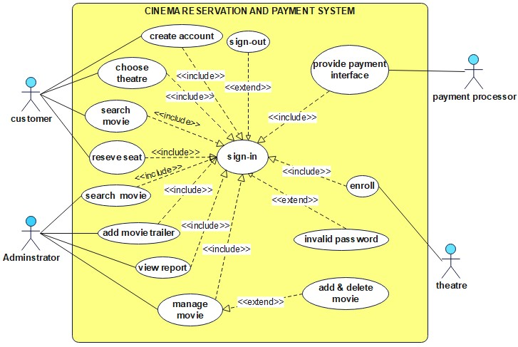

*Figure 1: use case diagram*

The following are the use cases with their corresponding use case identifiers:

*Table 7: use cases and their identifiers*

|  |  |
| --- | --- |
| **Use case name** | **Use case id** |
| Create account | UC-001 |
| Sign-in | UC-002 |
| enroll | UC-003 |
| choose theatre | UC-004 |
| Search movie | UC-005 |
| Reserve seat | UC-006 |
| Manage movie | UC-007 |
| Add movie trailer | UC-008 |
| View report | UC-009 |

**Use case description**

*Table 8: Create account description*

|  |  |  |  |
| --- | --- | --- | --- |
| **use case id** | **UC-001** | | |
| **Use case name** | Create account | | |
| **Actor** | Customer | | |
| **Description** | The system permits the creation of account by the customer. | | |
| **Pre-condition** | Need of the customer to create account. | | |
| **Flow of events** | **User action** | **system response** | |
| **1.** Customer presses on ’create account’ button.  **3.** customer enters the needed information and presses the ‘create account button’ | **2.** The account creation form is displayed to the customer.  **4.** The system validates the information entered by the customer.  **5.** System informs the customer that they have successfully created account. | |
| **Post-condition** | The customer will get to use the application. | | |
| **Alternative flows** | If Customer invalid credentials | | |
| **5.2** Customer enters the correct credentials | | **5.1** systems display warning or fault message “invalid input, please try again!” |

*Table 9: Sign-in description*

|  |  |  |
| --- | --- | --- |
| **use case id** | **UC-002** | |
| **Use case name** | Sign-in | |
| **Actor** | Administrator and Customer | |
| **Description** | The system permits the Administrator and Customer to sign-in into the system. | |
| **Pre-condition** | the Administrator and Customer must fulfill the required username and password to sign-in | |
| **Flow of events** | User action | system response |
| **1.** The Administrator and Customer presses on ’sign-in’ button.  **3** The Administrator and Customer enter the required username and password and press the ‘sign-in’ button. | **2.** The sign-in form is displayed by the system..  **4.** The system validates the information entered by the customer.  **5.** The system displays homepage. |
| **Post-condition** | The Administrator and Customer access their own pages. | |
| **Alternative flows** | If Administrator and Customer enters nullified or incorrect credentials | |
| **5.2** The Administrator and Customer enters the correct credentials | **5.1** systems display warning or fault message “credentials are wrong, please try again!” |

*Table 10: enroll description*

|  |  |  |  |
| --- | --- | --- | --- |
| **use case id** | **UC-003** | | |
| **Use case name** | enroll | | |
| **Actor** | Theatre | | |
| **Description** | Theatre organizations are permitted to register into the account. | | |
| **Pre-condition** | The theatre organization wanting to enroll into the system. | | |
| **Flow of events** | **User action** | **system response** | |
| **1.** The theatre presses on ‘enroll theatre’ button.  **3.** The theatre enters the required information and press the ‘enroll theatre’ button. | **2.** The enrollment form is displayed by the system..  **4**. The system validates the information entered by the theatre.  **5.** System informs the theatre organization that they have successfully created account.  . | |
| **Post-condition** | The theatre organization will be enrolled into the system. | | |
| **Alternative flows** | If theater enters invalid input | | |
| **5.2** The theatre enters the correct input | | **5.1** systems display warning or fault message “input is wrong, please try again!” |

*Table 11: choose theatre description*

|  |  |  |  |
| --- | --- | --- | --- |
| **use case id** | **UC-004** | | |
| **Use case name** | choose theatre | | |
| **Actor** | customer | | |
| **Description** | The system permits the customer to choose preferred theatre. | | |
| **Pre-condition** | The customer should sign-in into the site or application. | | |
| **Flow of events** | **User action** | **system response** | |
| **1.** The customer presses on ‘search theatre’ button.  **3.** customers will choose preferred theatre.  **4.** End use case. | **2.** The system displays available theatres.  . | |
| **Post-condition** | The available theatres will be visited and chosen by the customer | | |
| **Alternative flows** | If customer chooses nonexistent theatre | | |
| **4.2** The customer chooses the correct theatre | | **4.1** systems display warning or fault message “wrong theatre, please choose again!” |

*Table 12: search movie description*

|  |  |  |  |
| --- | --- | --- | --- |
| **use case id** | **UC-005** | | |
| **Use case name** | Search movie | | |
| **Actor** | Customer and administrator | | |
| **Description** | The system permits the search of movie schedule by the customer and administrator | | |
| **Pre-condition** | The customer and administrator should sign-in into the site or application. | | |
| **Flow of events** | **User action** | | **system response** |
| **1.** The customer and employee presses on ‘movie schedule’ button.  **3.** The customer and administrator will visit the movie schedule.  **4.** end use case | | **2.** the system displays the movie schedule |
| **Post-condition** | The movie schedule will be accessed by the customer and administrator. | | |
| **Alternative flows** | If customer or administrator searches for nonexistent movie | | |
| **4.2** The customer or administrator searches again for the correct movie | **4.1** systems display warning or fault message “movie doesn’t exist, please search again!” | |

*Table 13: Reserve seat description*

|  |  |  |  |
| --- | --- | --- | --- |
| **use case id** | **UC-006** | | |
| **Use case name** | Reserve seat | | |
| **Actor** | Customer | | |
| **Description** | The system permits the customer to reserve seat. | | |
| **Pre-condition** | The customer should sign-in into the site or application. | | |
| **Flow of events** | **User action** | | **system response** |
| **1.** The customer presses on ‘movie schedule’ button.  **3.** The customer presses on the button ‘movie detail’ button.  **7.** Customer chooses seat. | | **2**. the system displays the movie schedule  **4.** System displays movie detail.  **6.** The system displays available seats.  **8.** The system validates process and reserves seat. |
| **Post-condition** | Customer reserves seat | | |
| **Alternative flow** | If seat is reserved | | |
| **8.2** go back to flow event #2 | **8.1** the system gives error message “ seat is taken” | |

*Table 14: Manage movie description*

|  |  |  |  |
| --- | --- | --- | --- |
| **use case id** | **UC-007** | | |
| **Use case name** | Manage movie | | |
| **Actor** | administrator | | |
| **Description** | The system permits the administrator to add and delete from the movie schedule. | | |
| **Pre-condition** | Administrator should sign-in into the site or application using their valid credentials. | | |
| **Flow of events** | **User action** | | **system response** |
| **1.** The admin presses on ‘manage movie schedule’ button.  **3.** the admin presses add or delete movie schedule button  **5.** end use case. | | **2.** The system displays the manage movie schedule interface.  **4.** the system will check the validity and display “successfully managed” message |
| **Post-condition** | Change made onto the movie schedule will be recorded in the database. | | |
| **Alternative flow** | If admin enters nullified or incorrect information | | |
| **5.2** go back to flow of event #2 | **5.1** the system gives error message “ invalid token” | |

*Table 15: add movie trailer description*

|  |  |  |  |
| --- | --- | --- | --- |
| **use case id** | **UC-008** | | |
| **Use case name** | Add movie trailer | | |
| **Actor** | Administrator | | |
| **Description** | The system permits the Administrator to add a movie trailer. | | |
| **Pre-condition** | The Administrator should sign-in into the site or application using the valid credentials. | | |
| **Flow of events** | **User action** | | **system response** |
| **1.** The Administrator presses on add movie trailer’ button.  **3.** The Administrator insert movie and presses the button ‘add trailer’.  **5**. End use case. | | **2.** The system displays the add movie trailer interface.  **4.** the system will check the validity and display “movie trailer successfully posted! ” message |
| **Post-condition** | Trailer of a movie will be posted. | | |
| **Alternative flow** | If Administrator enters nullified or incorrect information | | |
| **5.2** go back to flow of event #3 | **5.1** The system gives fault message “invalid token”. | |

*Table 16: view report description*

|  |  |  |  |
| --- | --- | --- | --- |
| **use case id** | **UC-009** | | |
| **Use case name** | View report | | |
| **Actor** | Administrator | | |
| **Description** | The system permits the administrator to view report. | | |
| **Pre-condition** | The administrator should sign-in into the site or application using the valid credentials. | | |
| **Flow of events** | **User action** | **system response** | |
| **1.** The administrator presses on ‘view report’ button.  **3.** The administrator presses on the ‘view report’ button.  **5.** administrator views report  **6.** End use case. | **2.** The system displays the report page.  **4**. The system retrieves the required report and displays report. | |
| **Post-condition** | Administrator views report at anytime. | | |
| **Alternative flow** | If Administrator enters nullified or incorrect information | | |
| **6.2** go back to flow of event #3 | | **6.1** The system gives fault message “invalid report request”. |

### 3.4.3. Sequence Diagram

A **sequence diagram** depicts how things interact with one another through a series of messages. It also illustrates the lifetimes of objects in relation to those messages.

Sequence Diagrams are interaction diagrams that show how operations are performed. They document the interaction of items in the context of a collaborative effort. Sequence Diagrams are time focused, and they graphically express the sequence of the interaction by utilizing the vertical axis of the diagram to indicate time, what messages are conveyed, and when.

Sequence Diagrams depict:

* The interaction that occurs in a partnership to actualize a use case or an activity (instance diagrams or generic diagrams).
* high-level interactions between the system's user and the system, the system and other systems, or subsystems (sometimes known as system sequence diagrams)

Here are the sequence diagrams for each action:

C:\Users\DDM TRADING\Desktop\Sequence Diagrams\register SD2.tiff

*Figure 2: sequence diagram for sign-in*

**C:\Users\DDM TRADING\Documents\ha.tiff**

*Figure 3: sequence diagram for sign-in*

**C:\Users\DDM TRADING\Desktop\Sequence Diagrams\enrollment SD.tiff**

*Figure 4: sequence diagram for enroll*

**C:\Users\DDM TRADING\Desktop\Sequence Diagrams\search theatre SD.tiff**

*Figure 5: sequence diagram for choose theatre*

**C:\Users\DDM TRADING\Desktop\Sequence Diagrams\search movie SD.tiff**

*Figure 6: sequence diagram for search movie*

**C:\Users\DDM TRADING\Desktop\Sequence Diagrams\reserve SD.tiff**

*Figure 7: sequence diagram for reserve seat*

**C:\Users\DDM TRADING\Desktop\Sequence Diagrams\manage movie SD.tiff**

*Figure 8: sequence diagram for manage movie*

**C:\Users\DDM TRADING\Desktop\Sequence Diagrams\add trailer SD.tiff**

*Figure 9: sequence diagram for add trailer*

**C:\Users\DDM TRADING\Desktop\Sequence Diagrams\view report SD.tiff**

*Figure 10: sequence diagram for view report*

### 3.4.4. Activity Diagram

An activity diagram depicts the dynamic character of a system by simulating the flow of control from one activity to the next. An activity describes a system operation on some class that results in a change in the system's state. Activity diagrams are commonly used to describe workflow, business processes, and internal operations. Because an activity diagram is a subset of a state chart diagram, it shares similar modeling patterns. Activity diagrams are primarily utilized as a flow chart that depicts the actions carried out by the system. An Activity Diagram is similar to a flow chart, with the exception that activity diagrams may depict simultaneous processing.

The activity diagrams of each process are as follows:

C:\Users\DDM TRADING\Desktop\Activity diagrams\sign-up AD.tiff

*Figure 11: activity diagram for sign-up*

C:\Users\DDM TRADING\Desktop\Activity diagrams\sign-in AD.tiff

*Figure 12: activity diagram for sign-in*

C:\Users\DDM TRADING\Desktop\Activity diagrams\enroll theatre AD.tiff

*Figure 13: activity diagram for Enroll*

C:\Users\DDM TRADING\Desktop\Activity diagrams\search movie AD.tiffC:\Users\DDM TRADING\Desktop\Activity diagrams\search theatre AD.tiff

*Figure 14: activity diagram for search movie*

*Figure 15: activity diagram for search theatre*

C:\Users\DDM TRADING\Desktop\Activity diagrams\manage movie AD.tiffC:\Users\DDM TRADING\Desktop\Activity diagrams\reserve AD.tiff

*Figure 16: activity diagram for manage movie*

*Figure 17: activity diagram for reserve seat*

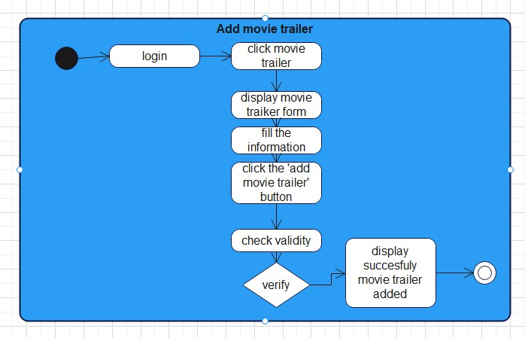

*Figure 18: activity diagram for add-movie trailer*

**C:\Users\DDM TRADING\Desktop\Activity diagrams\view report AD.tiff**

*Figure 19: activity diagram for view report*

### 3.4.5. Analysis Level Class diagram

A class diagram depicts the structure of a system by displaying the classes, their properties, and the relationships between the classes. Class diagrams are essential to the object modeling process because they represent the system's static structure. Depending on the complexity of the system, you can use a single class diagram to model the complete system or numerous class diagrams to model the system's components.

Class diagrams are your system's or subsystem's blueprints. Class diagrams may be used to represent the items that comprise the system, depict the relationships between the objects, and define what those objects perform and the services they offer.

Class diagrams are useful throughout the system design process. A class diagram can assist you grasp the requirements of your issue domain and identify its components during the analysis stage. The class diagrams that you develop during the early phases of an object-oriented software project contain classes that often transform into actual software classes and objects when you write code. You may further enhance your earlier analyses and conceptual models into class diagrams that depict the precise pieces of your system, user interfaces, logical implementations, and so forth. Your class diagrams will then be a snapshot that specifies exactly how your system works, the relationships between system components at various levels, and how you intend to implement those components.

Here is the system analysis diagram:

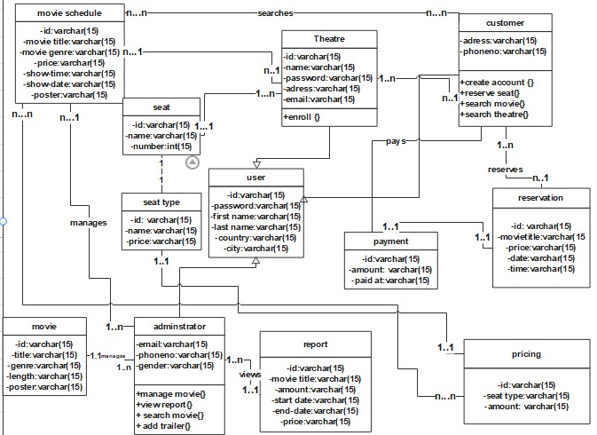

*Figure 20: class diagram for cinema reservation system*

### 3.4.6. User Interface Design

User interface (UI) design, also known as user interface engineering, is the process of creating user interfaces for equipment and software such as computers, home appliances, mobile devices, and other electronic devices with the goal of optimizing usability and user experience. The purpose of user interface design is to make the user's interaction with the system as easy and efficient as feasible in terms of achieving user goals (user-centered design).

A good user interface design aids in the completion of the task at hand without calling undue attention to itself. Graphic design and typography are used to assist its usability, affecting how the user performs specific interactions and boosting the design's visual appeal; design aesthetics may increase or detract from users' ability to use the interface's functionality. At the end of the project the user interface of our application will be something similar to the following images:

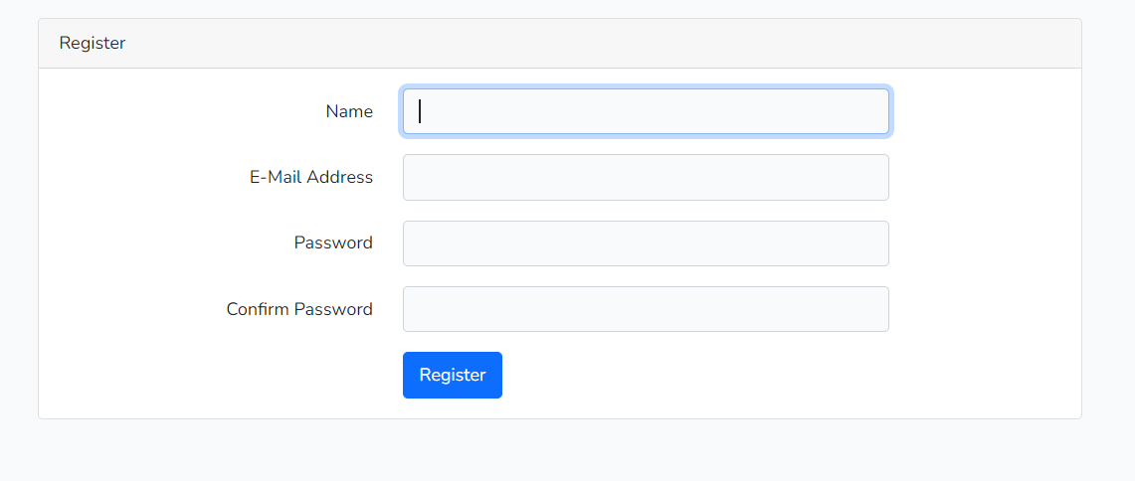

*Figure 21: UI design for sign-up*

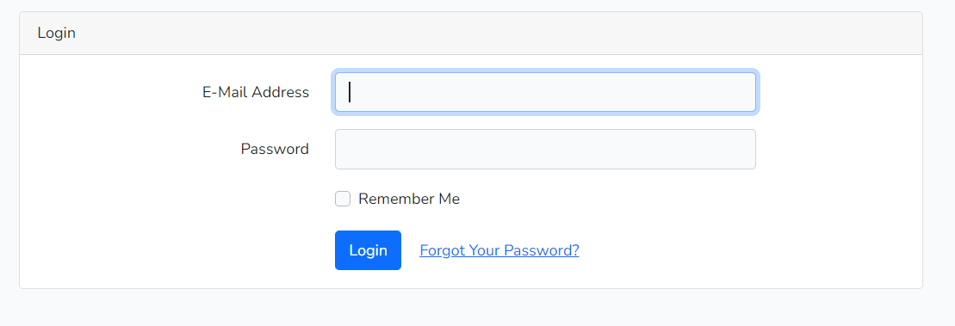

*Figure 22: UI design for sign-in*

### 3.4.7. User Interface Prototyping

A user interface is a graphical component of a computer program or operating system that allows a user to interact with a computer or software. It controls how orders are sent to the computer or program, as well as how information is shown on the displays. However, users access this system capabilities based on their roles when they log in to the system.

A user interface prototype is a low-fidelity mockup or prototype of the system's user interface. A user interface assists the team in modeling large UI components such as screens and reports, as well as minor UI elements such as input fields and lists. We attempt to demonstrate these interfaces in general using a simple prototype:

C:\Users\DDM TRADING\Desktop\UI prototype\user interface prototype.tiff

*Figure 23: user interface prototyping*

# CHAPTER FOUR

# 4. SYSTEM DESIGN

## 4.1. INTRODUCTION

We went over the design model analysis in detail in the last chapter. In this chapter of the project, we will look at our project's system design. It includes and explains logic, view, process view, deployment diagram, ER diagram and Database design.

The transition of the analytical model into a system design model is known as system design. The primary goal of system design is to demonstrate how the system is developed and to gather clear and sufficient information to drive the system's real execution.

Also, demonstrate the direction in which the application is constructed, as well as acquire clear and sufficient information to drive the actual execution of the program. The application is built on system design and is based on an understanding of the model. It also focuses on decomposing the system into manageable sections.

## 4.2. Purpose of the System Design Document (SDD)

The major goal of the suggested system is to prevent (reduce) the existing system problem, which is so tiresome and bothersome, and to create a fast and user-friendly system, as well as to simplify and minimize the complexity of the cinema reservation and payment process. Furthermore, to reduce security issues and speed up the system's overall activity/operation, the new system overcomes the problem of the previous system by offering well-organized, pleasant conditions for the client, and simplifying the burden of the worker at the ticket booth.

## 4.3. Design Goal

Design goals originate from the system's nonfunctional requirements, which are the description of the system's feature traits and attributes, as well as any limitations that may limit the proposed solution's boundaries. The features of the system that should be optimized are described by design goals. In addition, create a model of good quality. The purpose of system design is to manage complexity by breaking it down into digestible chunks. Some of the objectives are given below:

1. **Modifiability:** The system should be able to be modified to provide different services based on the needs of the user.
2. **Flexibility**: The system should be adaptable to changing conditions or situations.
3. **Efficienc**y: The system must accomplish what it is designed to do in an efficient and error-free manner.
4. **Accessibility** is one of the finest features of the suggested system. Users may obtain current information no matter where they are in the country. To trace some of its best accessible characteristics, such as: It is available without regard to geographical location. It is available without time constraints - users can offer their ideas at any moment.
5. **Performance** refers to the system's speed and the amount of space it requires. As a result, the three performance criteria listed below have been identified.
6. **Dependability**: This criterion dictates how much work will be required to reduce system breakdowns and their effects. The following have been established as the primary dependability criteria.
7. **Robustness**: By verifying all user inputs, the system should be able to tolerate invalid user input.
8. **Availability**: The system should be open to prospective users as long as voting is taking place. The work is completed in a matter of seconds.
9. **Reliability**: The system should act in a predictable manner. It should be able to authenticate all users, check all voter/user inputs, and perform additional processes to assure dependability.
10. **Fault Tolerance**: To ensure the system's fault tolerance, backup services of both the application and database servers will be maintained and switched to if the primary servers fail.
11. **Security**: Because the system is accessible to the public, it is vulnerable to vulnerabilities unless adequate security measures are implemented.
12. **Maintainability** is a criterion that defines how difficult it is to update the system once it has been deployed. It also impacts how simple it is to add new features. The following factors have been recognized as maintenance criteria.
13. **Extensibility**: Because the suggested system is based on an Object Oriented Design methodology, additional functions and classes may be readily implemented.
14. **Modifiable:** The finger print voting system should be fully documented so that it may be readily modified after deployment without interfering with the present functioning system.
15. **End User Criteria:** End user requirements are desired attributes from the user's perspective that have not yet been addressed by the performance and reliability criteria
16. **Usability:** The system should be user friendly so that users may quickly understand and utilize it without difficulty.

## 4.4. Architectural Design

### 4.4.1. Logical View of the Architecture

**Logical view**: Describes the system's structure in terms of implementation units. Packages, classes, and interfaces are the elements. Dependencies, interface realizations, part-whole linkages, and so on may be seen in the interaction between elements.

Here is what the logical view looks like:

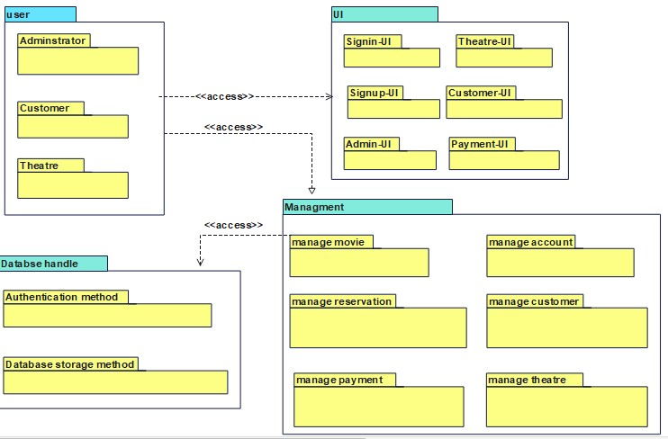

*Figure 24: logical view*

### 4.4.2. Process View

In the Analysis & Design discipline, an architectural perspective known as the process view is employed to offer a foundation for understanding the system's process structure. The system has just one process view, which depicts the system's process decomposition, including the mapping of classes and subsystems to processes and threads. Each iteration improves the process perspective. With UML, the static and dynamic aspects of this view are captured in the same kinds of diagrams as for the design view - i.e. class diagrams, interaction diagrams, activity diagrams, and state chart diagrams, but with a focus on the active classes that represent these threads and processes. The process view deals with the dynamic aspects of the system, explains the system processes and how they communicate, and focuses on the run time behavior of the system. The process view addresses concurrency, distribution, integrator, performance, and scalability, etc (wikipedia, 2019).

The process view is as follows:

C:\Users\DDM TRADING\Desktop\process view\process view.tiff

*Figure 25: process view*

### 4.4.3. Deployment View

This view specifies the context in which the system is run. It represents the system's geographical distribution or the structure of the hardware components that run the software. It describes workstations, processors, network topologies and channels, as well as other physical system environment features. The deployment view depicts the system from the perspective of the operator. Please describe how the building components of the systems are aggregated or bundled into deployment artifacts or deployment units.

Here is what the deployment view looks like:

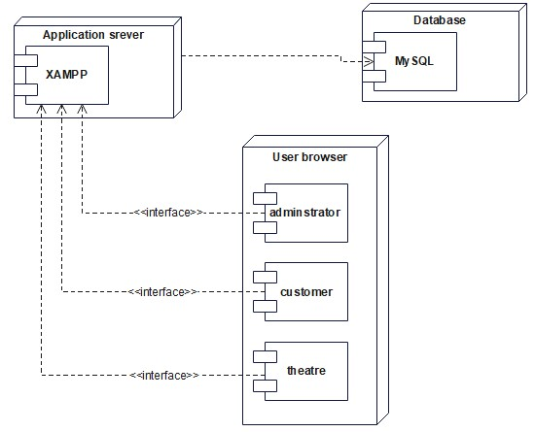

*Figure 26: deployment view*

## 4.5. Database Design

**Database Design** is a collection of processes that facilitate the designing, development, implementation and maintenance of enterprise data management systems. Properly designed database are easy to maintain, improves data consistency and are cost effective in terms of disk storage space. The database designer decides how the data elements correlate and what data must be stored.

The main objectives of database design in DBMS are to produce logical and physical designs models of the proposed database system. To elaborate, the logical model is largely focused on data needs, and considerations must be made in terms of monolithic concerns, and so the stored physical data must be stored independently of physical conditions. The physical database design model, on the other hand, involves a translation of the logical design model of the database by maintaining control of physical media utilizing hardware resources and software systems such as Database Management System (DBMS).

A correctly constructed database gives you access to up-to-date, reliable data. Because a good design is vital to achieve your goals while working with a database, it makes sense to invest the time necessary to study the concepts of good design. In the end, you are far more likely to have a database that fits your goals and is easily adaptable to change.

The following points describe the significant considerations that may be taken into account while stressing the importance of database design.

1. Database designs provide out the blueprints for how data will be stored in a system. A database's design has a significant impact on the overall performance of any program.
2. The database design principles outlined provide a clear picture of how every application behaves and how requests are processed.
3. Another reason to highlight database design is because a good database design serves all of the needs of the users.
4. Finally, if the restrictions of creating a highly efficient database are effectively applied, the processing time of an application is considerably decreased. The tables in our database are user, movie, theatre, seat type, seat, movie schedule, pricing, reservation, report payment and administrator. The tables look as follows:

|  |  |  |
| --- | --- | --- |
|  | **Customer** | **Data type** |
| **PK** | ID | Varchar(15) |
|  | Password | Varchar(15) |
|  | First_name | Varchar(15) |
|  | Last_name | Varchar(15) |
|  | Country | Varchar(15) |
|  | city | Varchar(15) |

|  |  |  |  |
| --- | --- | --- | --- |
|  | **Theatre** | **Data type** | |
| **PK** | ID | Varchar(15) | |
|  | Name | Varchar(15) | |
|  | Password | Varchar(15) | |
|  | Address | Varchar(15) | |
|  | Email | | Varchar(15) |

|  |  |  |
| --- | --- | --- |
|  | **Movie schedule** | **Data type** |
| **PK** | ID | Varchar(15) |
|  | MovieTitle | Varchar(15) |
|  | MovieGenre | Varchar(15) |
|  | ShowTime | Varchar(15) |
|  | ShowDate | Varchar(15) |
|  | Price | Varchar(15) |
|  | Poster | Varchar(15) |

|  |  |  |
| --- | --- | --- |
|  | **Seat** | **Data type** |
| PK | ID | Varchar(15) |
|  | Name | Varchar(15) |
|  | Number | Varchar(15) |

|  |  |  |  |
| --- | --- | --- | --- |
|  | **movie** | **Data type** | |
| **PK** | ID | Varchar(15) | |
|  | Genre | Varchar(15) | |
|  | Length | Varchar(15) | |
|  | Poster | Varchar(15) | |
|  | title | | Varchar(15) |

|  |  |  |
| --- | --- | --- |
|  | **Seat type** | **Data type** |
| **PK** | ID | Varchar(15) |
|  | Name | Varchar(15) |
|  | price | Varchar(15) |

|  |  |  |
| --- | --- | --- |
|  | **Payment** | **Data type** |
| **PK** | ID | Varchar(15) |
|  | amount | Int(15) |
|  | Paid_at | Varchar(15) |

|  |  |  |
| --- | --- | --- |
|  | **Administrator** | **Data type** |
| **PK** | ID | Varchar(15) |
|  | Email | Varchar(15) |
|  | Phone no | Varchar(15) |
|  | Gender | Varchar(15) |
|  | country | Varchar(15) |
|  | city | Varchar(15) |

|  |  |  |
| --- | --- | --- |
|  | **Pricing** | **Data type** |
| **PK** | ID | Varchar(15) |
|  | Seat_type | Varchar(15) |
|  | amount | Varchar(15) |

|  |  |  |
| --- | --- | --- |
|  | **Reservation** | **Data type** |
| **PK** | ID | Varchar(15) |
|  | Movie title | Varchar(15) |
|  | SeatNo | Varchar(15) |
|  | Time | Varchar(15) |
|  | Date | Varchar(15) |
|  | Price | Varchar(15) |

|  |  |  |
| --- | --- | --- |
|  | **Report** | **Data type** |
| **PK** | ID | Varchar(15) |
| **FK** | Movie_id | Varchar(15) |
|  | Amount | Varchar(15) |
|  | Start_date | Varchar(15) |
|  | End_date | Varchar(15) |

### 4.4.1. ER Diagram

An **Entity–relationship model (ER model)** describes the structure of a database with the help of a diagram, which is known as **Entity Relationship Diagram (ER Diagram)**. An ER model is a design or blueprint of a database that can later be implemented as a database. The main components of E-R model are: entity set and relationship set.

ER diagram shows the relationship among entity sets. An entity set is a group of similar entities and these entities can have attributes. In terms of DBMS, an entity is a table or attribute of a table in database, so by showing relationship among tables and their attributes, ER diagram shows the complete logical structure of a database.

The following diagram is the entity relationship diagram for the cinema reservation and payment system:

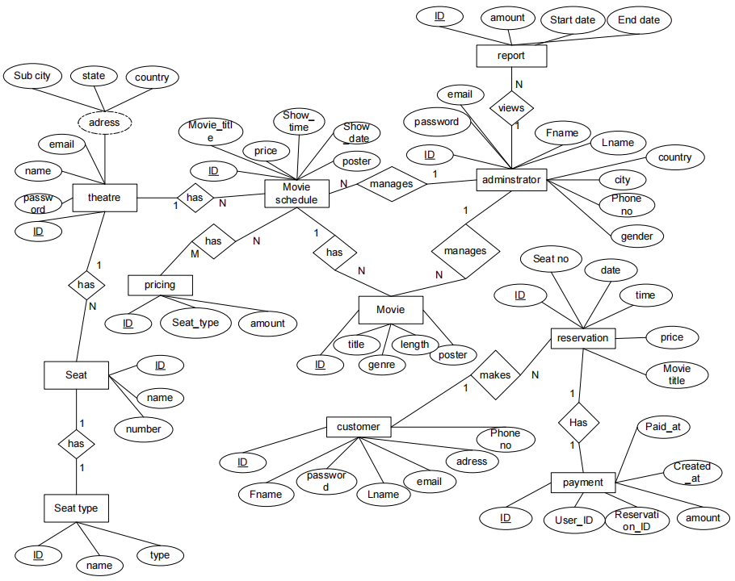

*Figure 27: ER-diagram*

### 4.4.2. Relational Mapping & Database Normalization

**1st normalization form**

|  |  |  |  |  |  |
| --- | --- | --- | --- | --- | --- |
| customer table | | | | | |
| id | **password** | **First_name** | **Last_name** | **country** | **city** |

|  |  |  |  |  |
| --- | --- | --- | --- | --- |
| Movie table | | | | |
| Id | **genre** | **length** | **poster** | **title** |

|  |  |  |  |  |
| --- | --- | --- | --- | --- |
| Theatre table | | | | |
| Id | **name** | **password** | **address** | **email** |

|  |  |  |
| --- | --- | --- |
| Seat type table | | |
| Id | **name** | **price** |

|  |  |  |
| --- | --- | --- |
| Seat table | | |
| Id | **name** | **number** |

|  |  |  |  |  |  |  |
| --- | --- | --- | --- | --- | --- | --- |
| Movie schedule table | | | | | | |
| id | **Movie title** | **Movie genre** | **Show time** | **Show date** | **price** | **poster** |

|  |  |  |
| --- | --- | --- |
| Pricing table | | |
| Id | **Seat type** | **amount** |

|  |  |  |  |  |  |
| --- | --- | --- | --- | --- | --- |
| Reservation table | | | | | |
| id | **Movie title** | **seat No** | **Time** | **date** | **price** |

|  |  |  |  |  |
| --- | --- | --- | --- | --- |
| Report table | | | | |
| Id | **Movie_id(FK)** | **amount** | **Start date** | **End date** |

|  |  |  |
| --- | --- | --- |
| Payment table | | |
| Id | **Amount** | **Paid at** |

|  |  |  |  |  |  |
| --- | --- | --- | --- | --- | --- |
| Administrator table | | | | | |
| Id | **Fname** | **Lname** | **password** | **country** | **city** |

**2nd normalization form**

|  |  |  |  |  |  |
| --- | --- | --- | --- | --- | --- |
| customer table | | | | | |
| Id | **password** | **First_name** | **Last_name** | **country** | **city** |

|  |  |  |  |
| --- | --- | --- | --- |
| Movie table | | | |
| Id | **genre** | **length** | **poster** |

|  |  |
| --- | --- |
| Theatre table | |
| Id | **name** |

|  |  |
| --- | --- |
| Seat type table | |
| Id | **name** |

|  |  |  |  |
| --- | --- | --- | --- |
| Seat table | | | |
| Id | **Type_id (FK)** | **name** | **Theatre_id(FK)** |

|  |  |  |  |  |
| --- | --- | --- | --- | --- |
| Movie schedule table | | | | |
| id | **Movie_id(FK)** | **Show time** | **Show date** | **Theatre_id(FK)** |

|  |  |  |  |
| --- | --- | --- | --- |
| Pricing table | | | |
| Id | **Seat type** | **amount** | **Movie_schedule_id(FK)** |

|  |  |  |  |  |
| --- | --- | --- | --- | --- |
| Reservation table | | | | |
| id | **customer_id(FK)** | **Seat_id(FK)** | **Movie_schedule_id(FK)** | **Pricing_id(FK)** |

|  |  |  |  |  |
| --- | --- | --- | --- | --- |
| Report table | | | | |
| Id | **Movie_id(FK)** | **amount** | **Start date** | **End date** |

|  |  |  |  |  |
| --- | --- | --- | --- | --- |
| Payment table | | | | |
| Id | **customer_id(FK)** | **Reservation_id(FK)** | **Amount** | **Paid at** |

|  |  |  |  |  |  |  |  |
| --- | --- | --- | --- | --- | --- | --- | --- |
| Administrator table | | | | | | | |
| Id | **Movie_id(FK)** | **Report_id(FK)** | **Fname** | **Lname** | **password** | **country** | **city** |

* The table now is now normalized and can’t be classified further!

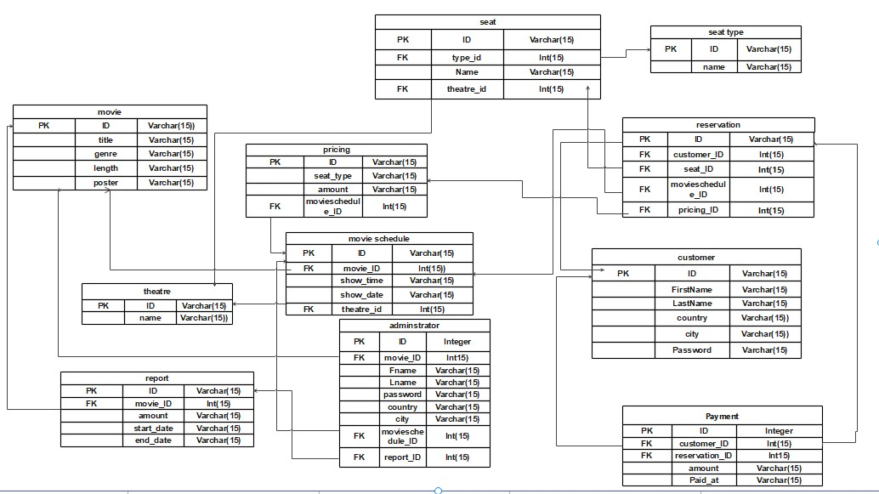

*Figure 28: Relational Mapping*

# CHAPTER FIVE

# 5. CONCLUSION AND RECOMMENDATION

## 5.1. CONCLUSION

In analyzing of the existing manual system, we found that services concerned with “cinema reservation and payment system” are not enough to serve the community in an efficient and effective way. This existing manual system is highly time consuming and creates a lot of work load on advisors, project coordinators and students. These leads to service delay, job and service dissatisfaction resulting in bankruptcy of a theatre organization.

So, after we have implemented this project we are sure that the existing problem of the system would find its solution because the project “web and android based cinema reservation and payment system” is intended to minimize the problem regarding cinema.

In this project we tried to gather different information about based cinema reservation and payment system and how their existing system works on a daily basis . we used the gathered data to put life into the cinema reservation and payment system by building it from scratch by using all software development life cycles like requirement gathering, requirement specification, system design, implementation, and configuration of the system.

The main focus of this project is to reduce human load and automate the manual system existing. The maintenance of the records is made efficient, as all the records are stored in the database, and also data can be retrieved easily and editing is also made simpler. Some of the aims of our project are:

* Minimize the time required to perform task.
* Minimize the work load at the ticket booth of a theatre.
* Increase customer satisfaction.

## 5.2. RECOMMENDATION

According to scope of our project the team will develop a web based and an android based application. Because of the time constraint we may have limitation which should be took as a consideration , but in the feature the team believes that this system should be fully operationally by adding some functionality that are not included in the proposed system. We recommend other teams to work on the following functionalities in the future:

* It would be easier to monitor and control the transaction process if the application was able to create its own simulation system for the payment process.
* It would be more convenient and user friendly if the application doesn’t had different pages for different theatres with different data.
* It would be financially advantageous if the application charges a subscription fee to for theaters enrollment process.
* It would be more convenient if the application gives refunding alternatives other than Yenepay
* More convenient if the application is able to provide GPS service for the theatres location
* The application will gain some financial gain if the system was able to advertise movies for theatre halls.

.

Finally the team would recommend that further work should be done on the system in order to make the system perform better for a theatre organization!

# References

* Airbrake. (2021, may 09). *What is Object-Oriented Analysis and Design and How To Use It*. Retrieved from Airbrake: https://airbrake.io/blog/design-patterns/object-oriented-analysis-and-design
* aws. (2020, OCT 03). *what is DevOps?* Retrieved from Amzon web services: https://aws.amazon.com/devops/what-is-devops/
* Denz, D. (2019, october 18 ). *why technology is important in our daily life*. Retrieved from Digital Denz: https://digitaledenz.com/why-technology-is-important-in-our-daily-life/
* enlab. (2021, may 19). *should startups build web and mobile applications with Flutter?* Retrieved from enlab: https://enlabsoftware.com/development/why-startup-choose-flutter-for-cross-platform-app-development.html
* flutter. (2021, oct 12). *Flutter - Build apps for any screen*. Retrieved from flutter: https://flutter.dev/
* github. (2019, oct 13). *YenePay Financial Technologies PLC - GitHub*. Retrieved from github: https://github.com/YenePay
* logic, s. (2021, nov 09). *What is Software Deployment?* Retrieved from SUMO LOGIC: https://www.sumologic.com/glossary/software-deployment/
* perforce. (2021, may 18). *what is flutter framework?* Retrieved from perfecto: https://www.perfecto.io/blog/what-is-flutter-framework
* wikipedia. (2019, oct 12). *4+1 architectural view mode*. Retrieved from wikipedia: https://en.wikipedia.org/wiki/4%2B1_architectural_view_model

**Appendices**

We are final year students of the faculty of information system in Hawassa University. We are doing/developing a project on a cinema reservation and payment system to automate it into a computerized system. Therefore, we need your positive attitude towards giving us the general working of the cinema system for not more than 30 minutes.

**Interview Questions**

1. What are the basic tasks that are performed in cinema business?
2. What are the different actors present in the cinema business?
3. How do you arrange seats in the cinema business?
4. How do you adjust assign schedules for the movies?
5. How often do you adjust the schedule of movies?
6. Is there any computerized system developed for a cinema reservation system before?
7. Do you think the computerized system will be helpful for you?
8. Is there anything you think is better to be included in the project?
9. Finally, if you have something you want to say us?